1. select iname, ccode from instructor, teach;

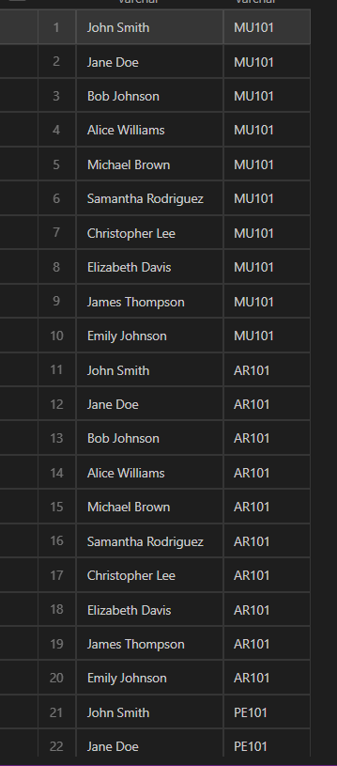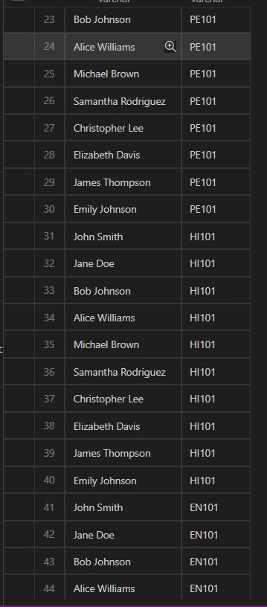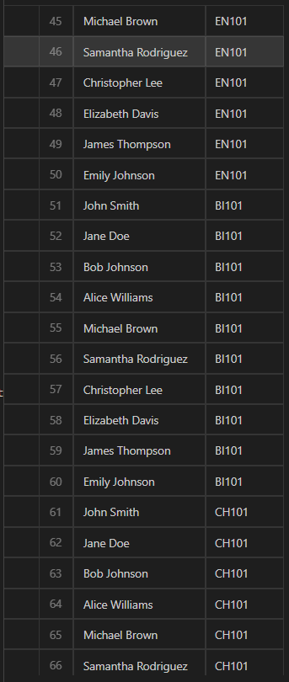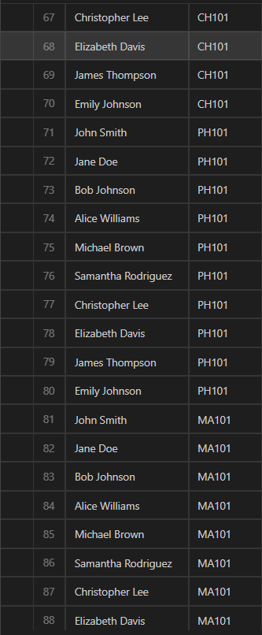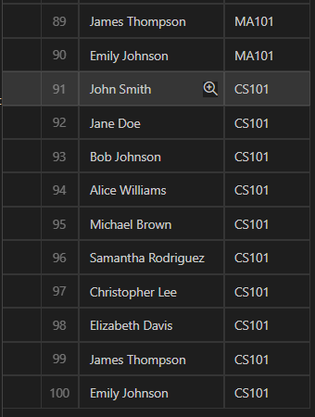

Cartition product of instructor and teach

1. select iname, CCode from instructor, teach where instructor.Id= teach.ID;

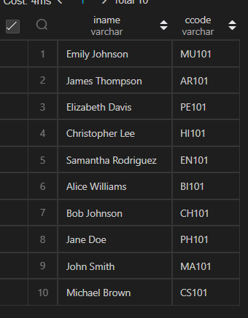Natual join

1. select iname, CCode from instructor natural join teach;

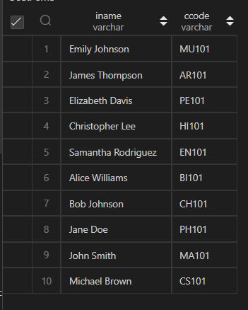 different way to use natural join

1. select instructor.iname, teach.ccode from instructor natural join teach;

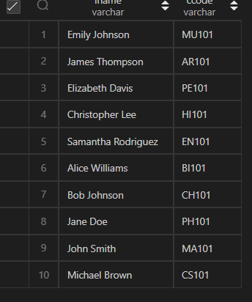

1. select * from student join take on student.SID= take.SID;

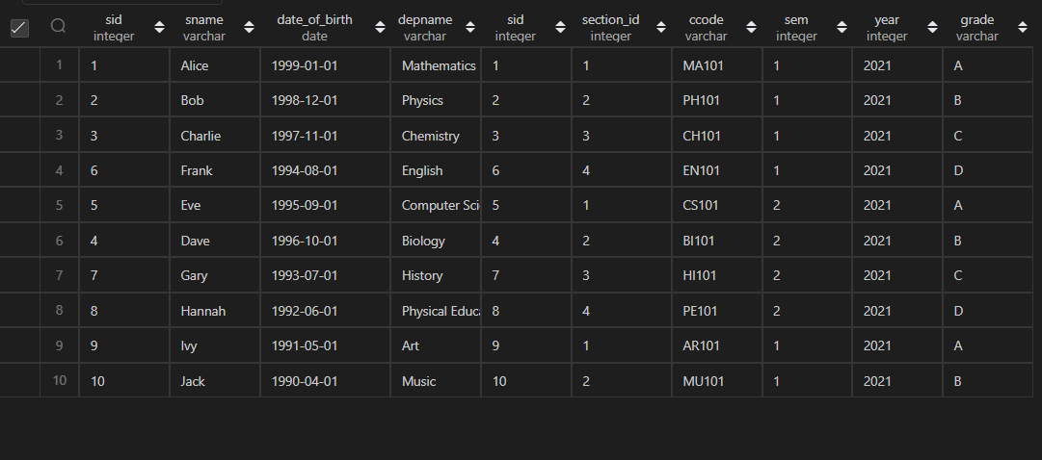

1. select * from student, take where student.SID= take.SID;

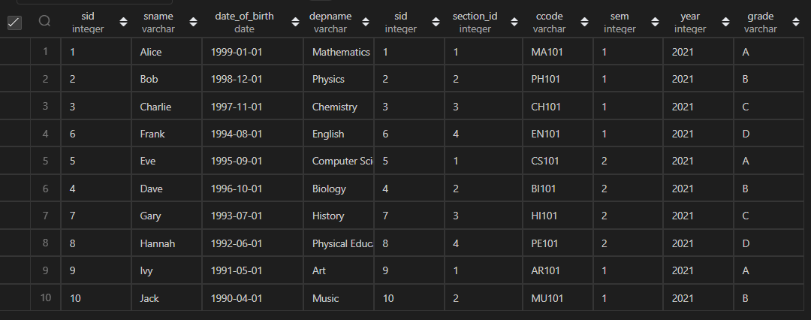

1. select student.SID as ID, sname, depname,ccode, section_id, sem, year, grade from student join take on student.sid= take.SID;

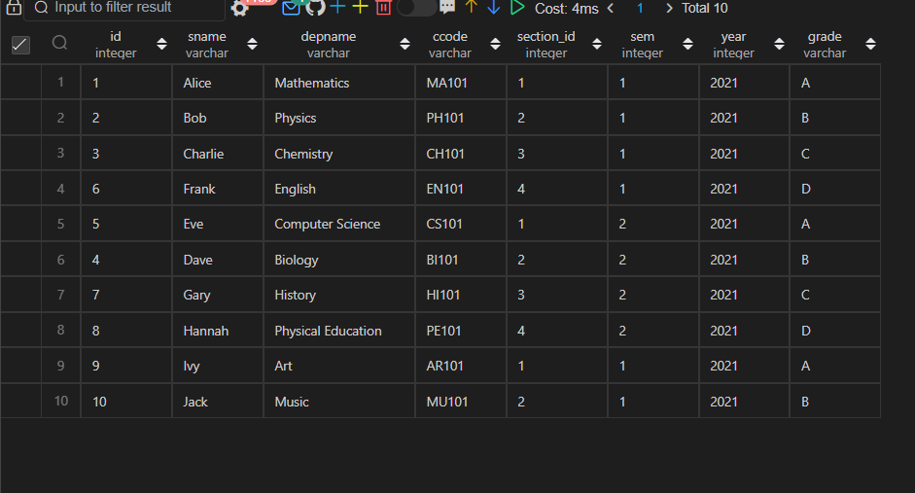

1. select iname, designation from instructor natural join teach, course where teach.ccode= course.ccode;

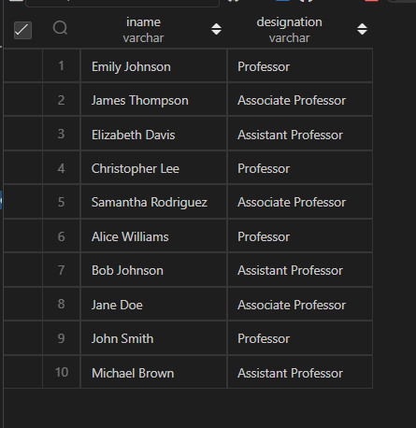

1. select iname, designation from instructor natural join teach natural join course;

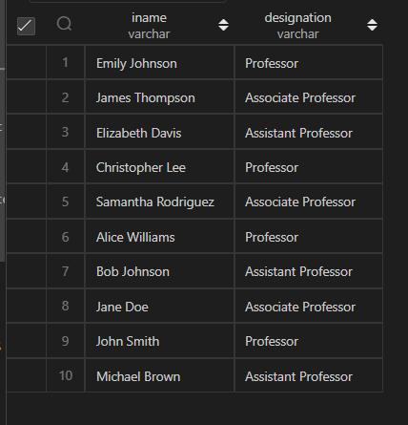

1. select iname, designation from (instructor natural join teach) join course using (ccode);

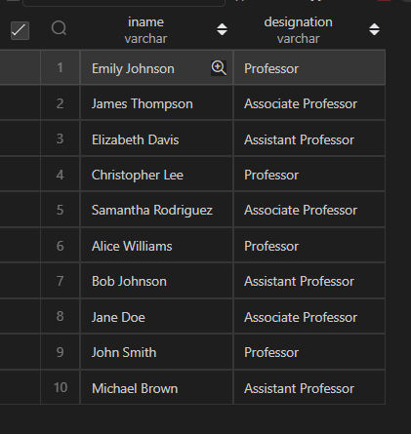

1. select * from student natural left outer join take;

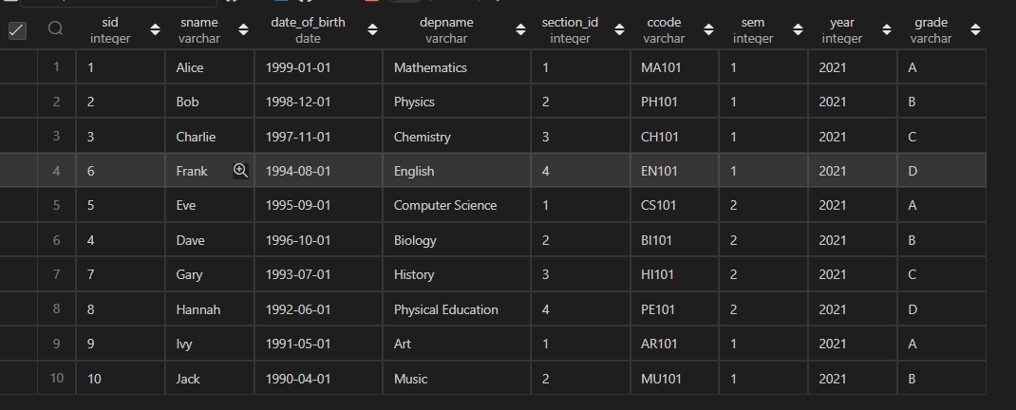

1. select ID from student natural left outer join takewhere ccodeis null;

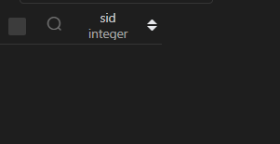

1. select * from takenatural right outer join student;

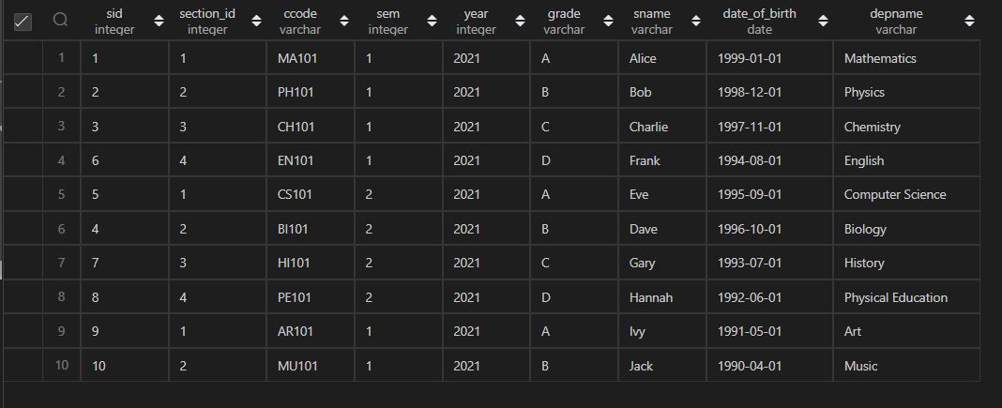

A. Display the name of the instructors along with the location of the department in which they work.

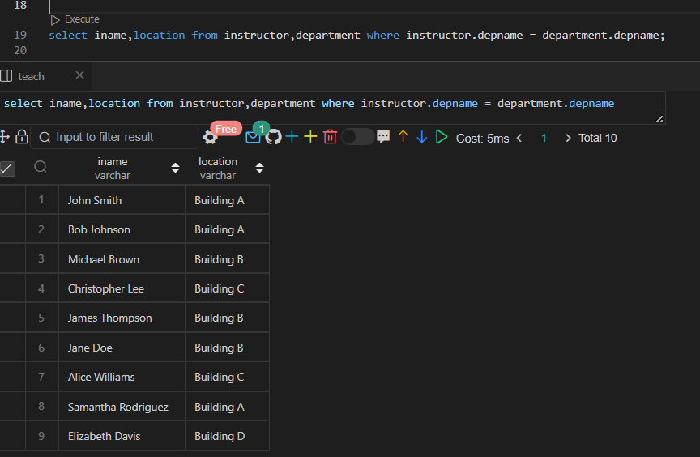

b. Display the name of the instructors along with the name of the courses they teach.

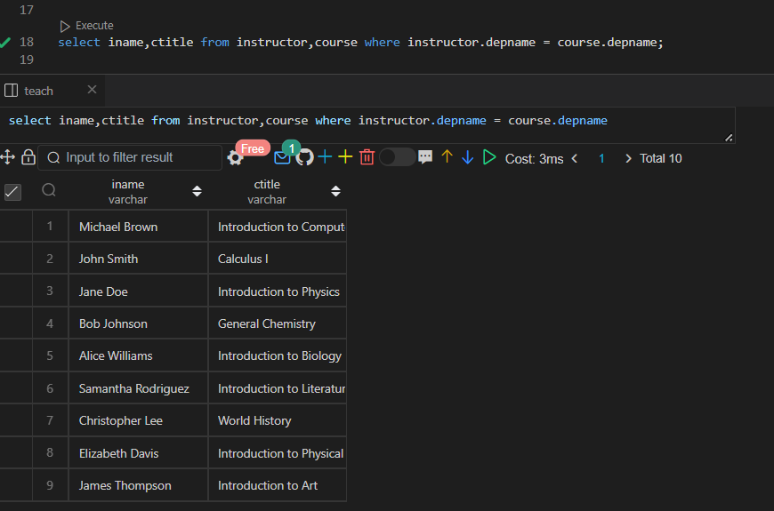

c. Add a column gender to the instructor table and update with data.

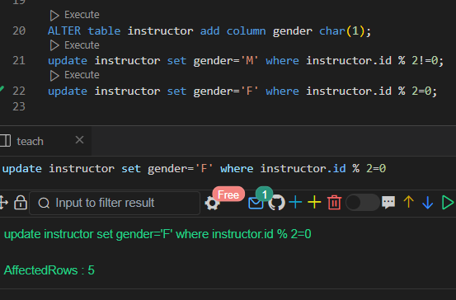

d. List female instructor name, course name and ccode of courses she teach.

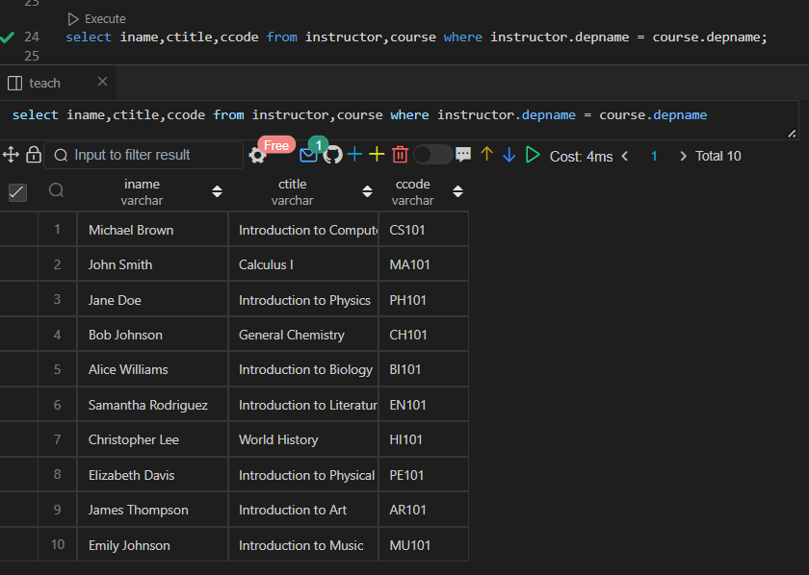

e. List the name of the course and the budget of the department that offers it.

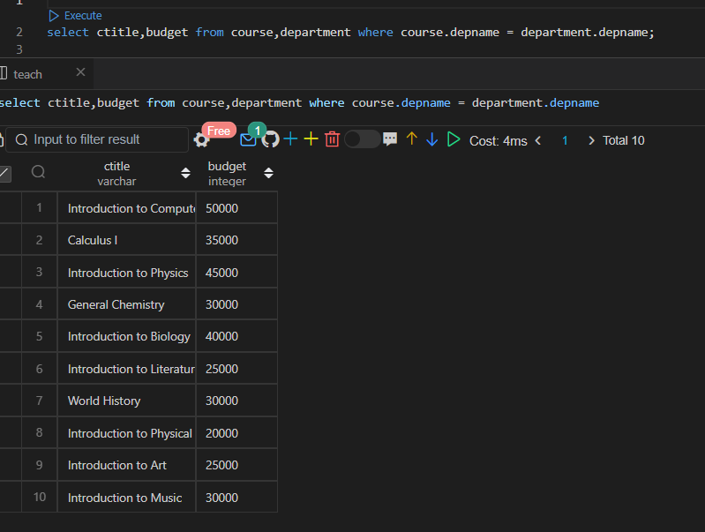

f. List the name of instructors who teaches a course titled ‘Operating Systems’.

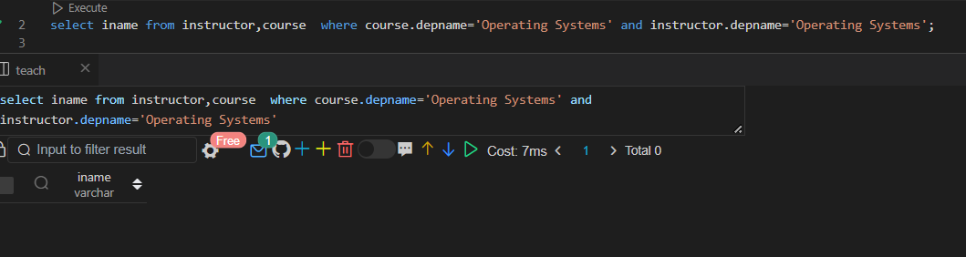

g. List department name and count of instructors in each departments that have more than 2 instructors, ordered by department name.

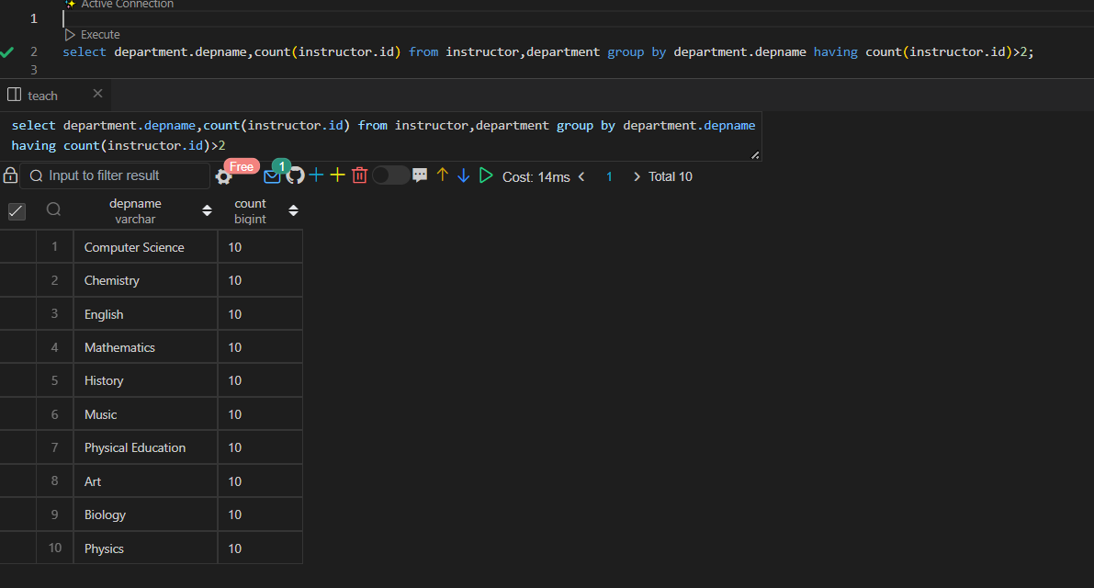

h. Find the name of the instructor and the name of the course taught by him in 2016.

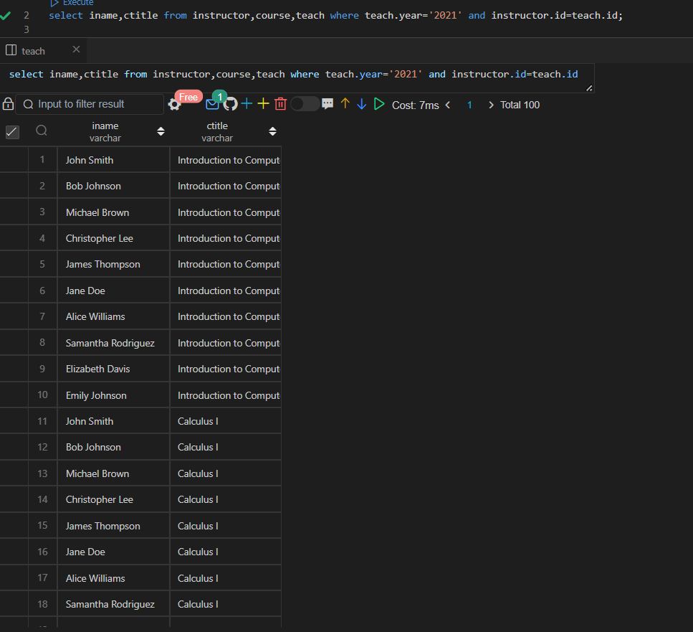

i. Find the name of the instructors of the CS department and the name of the course taught by him in 2016.

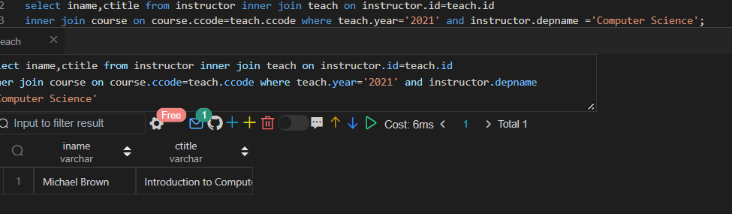

j. Find the name of all the students who have registered for a course titled ‘DBMS’ and got an ‘A’ grade.

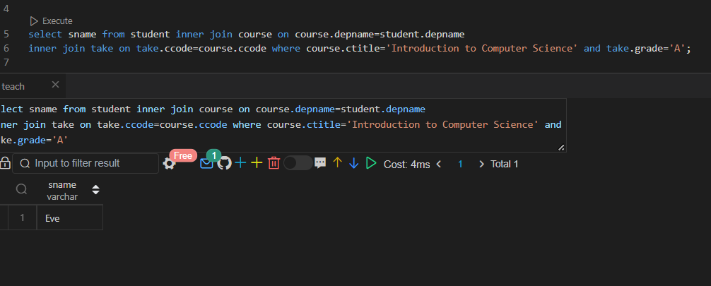

k. Find the ID of students who have registered for a DBMS course in 2017.

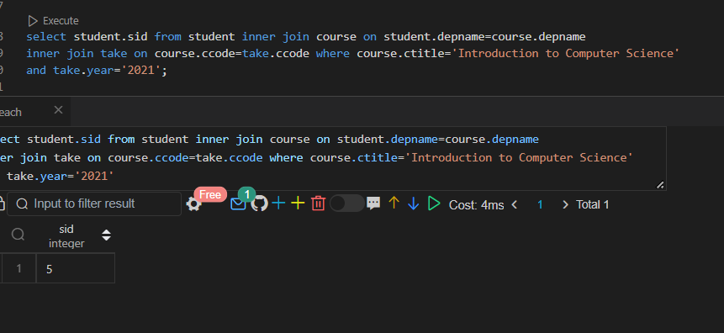

l. For each instructor, display the total number of courses taught by him.

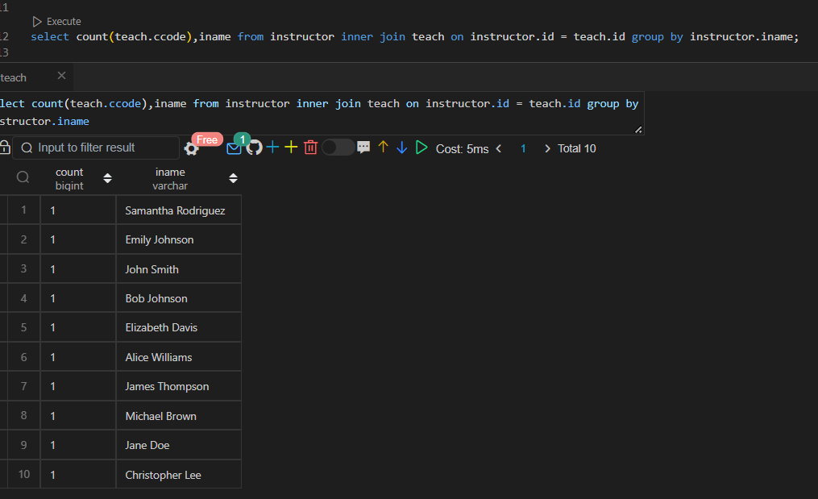

m. For each instructor, display the total number of courses taught by him in 2017.

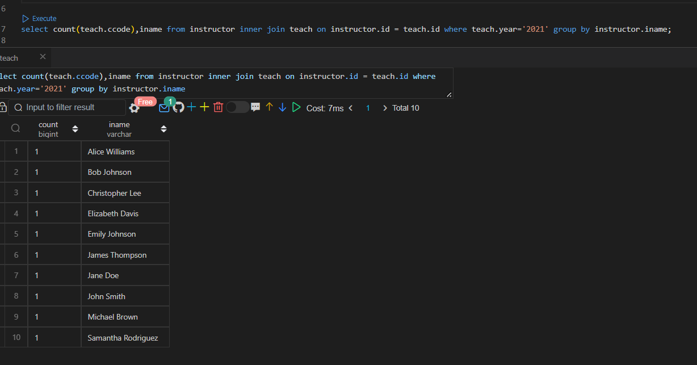

n. Find the name of the instructors working in the departments located in Main block building.

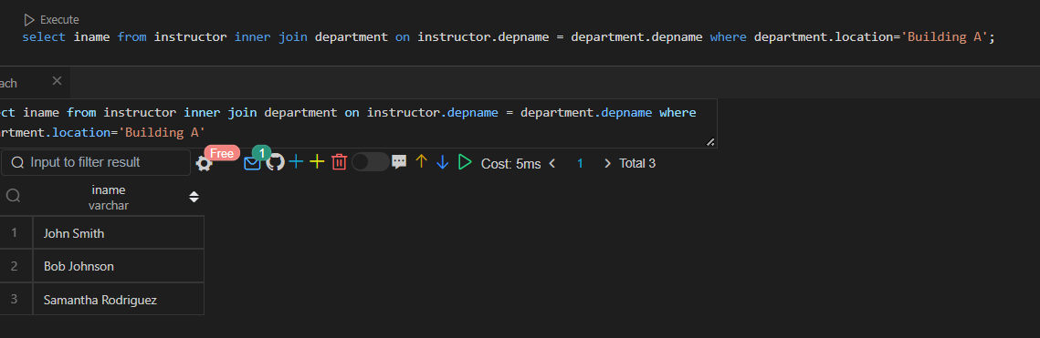

o. Find the name of the instructor who taught C programming for CS department in 2ndsemester 2017.

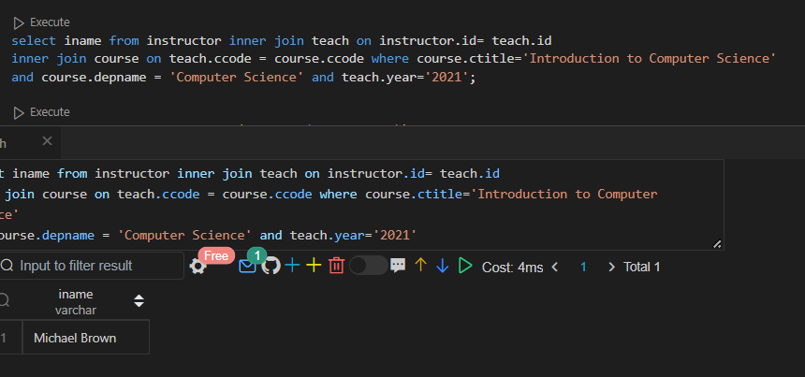

p. Find the number of times each course has been taught by each instructor.

